**Guidelines to fill the Application Form**

1. On receiving the interview call letter on your registered e-mail ID, please click on the following link:

<http://www.infosys.com/careers/job-opportunities/>

1. Please click on the ‘Login’ tab under the Experienced Professionals section for Job openings in India (kindly refer to the screen shot below)

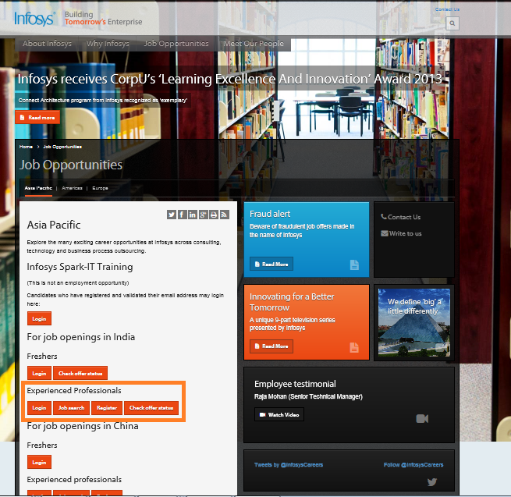

1. Login pop-up will open, prompting you to enter the email id and password. Please login with your registered email ID and the password which was shared with you in a mail from [TALENTACQUISITION@infosys.com](mailto:TALENTACQUISITION@infosys.com).

In case you do not recollect your password or face trouble logging in, please click on the ‘Forgot Password’ link as shown below to reset your password. The new password will be mailed to you within a couple of hours. Kindly check your spam mailbox as well since there is a possibility of the mail going to spam.

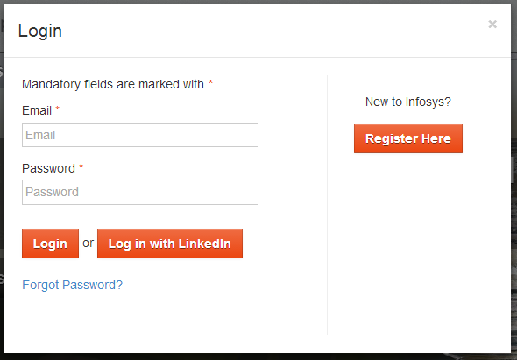

1. Upon logging in, you will be directed to your account in the careers site. The status and percentage completion of the application form will be displayed in the Application Form widget. Please click on ‘Complete’ button to fill the application form.

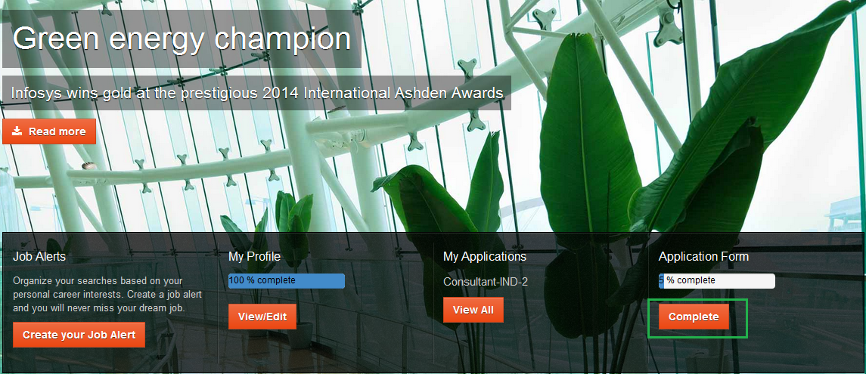

1. On clicking the ‘Complete’ button, you will be redirected to the application form where you will need to fill in all the mandatory fields. The details provided while applying for the job will be pre-filled and displayed here.

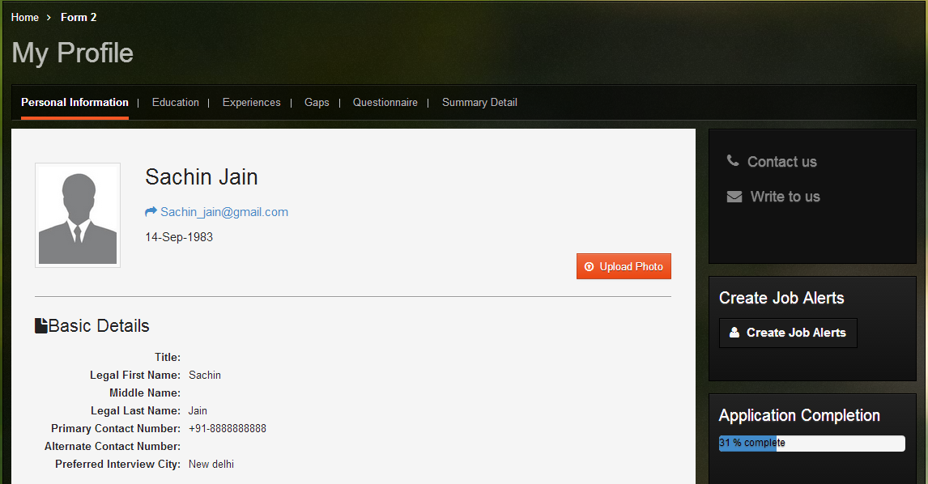

Please complete all the sections of the application form – do keep your mark-sheets, experience certificates and a soft copy of the passport size photograph handy while filling the application form. Kindly fill up all the details accurately in accordance with your supporting documents.

Each section of the Application Form is explained below:

1. **Personal Information -** This section will capture following details:

* **Upload Photograph** – here you will need to upload your photograph.

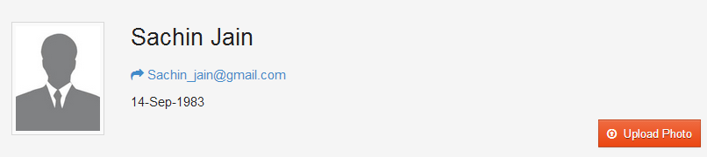

On clicking the **‘Upload Photo’ tab,** below pop up will open, asking you to choose the file. Only one photograph can be uploaded at a time.

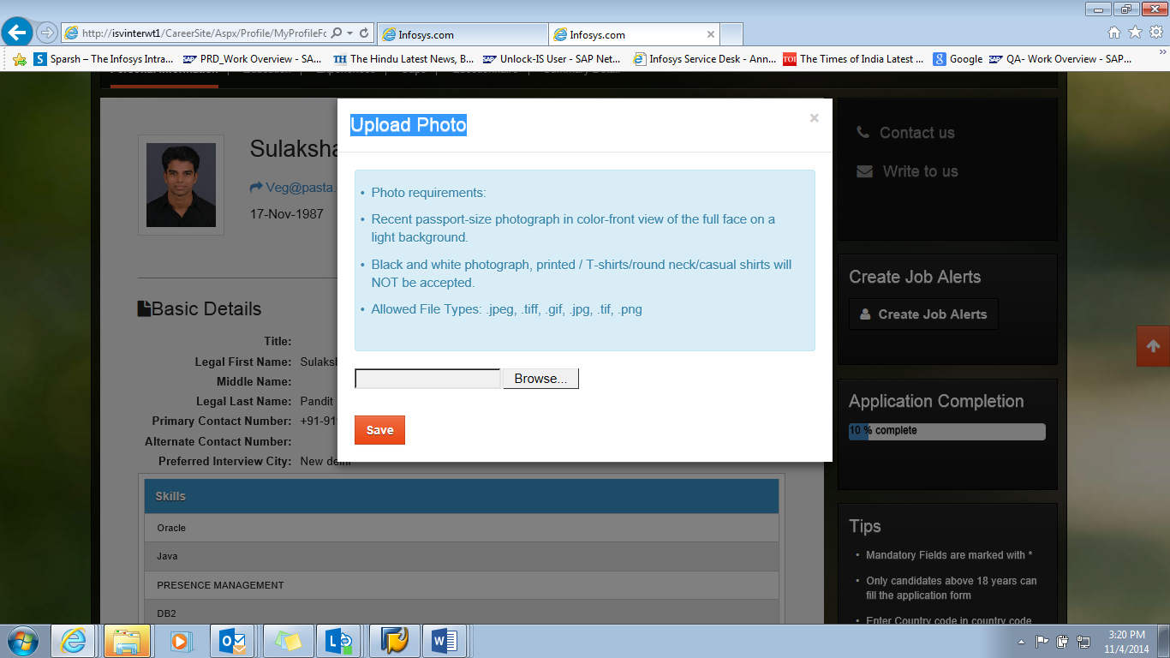

Once saved and uploaded, the photograph will start reflecting on your profile.

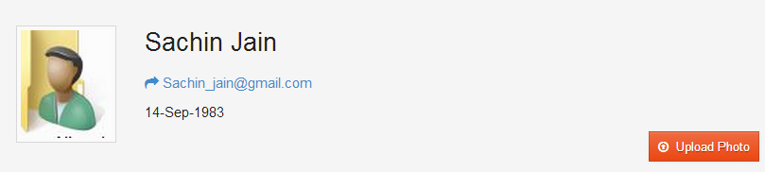

* **Basic Details -** This section will show your basic details.

Clicking on “Edit” button will display the fields in editable mode. If you wish to add more than one skill, you can click on “+” button. You also have an option to delete the skills added.

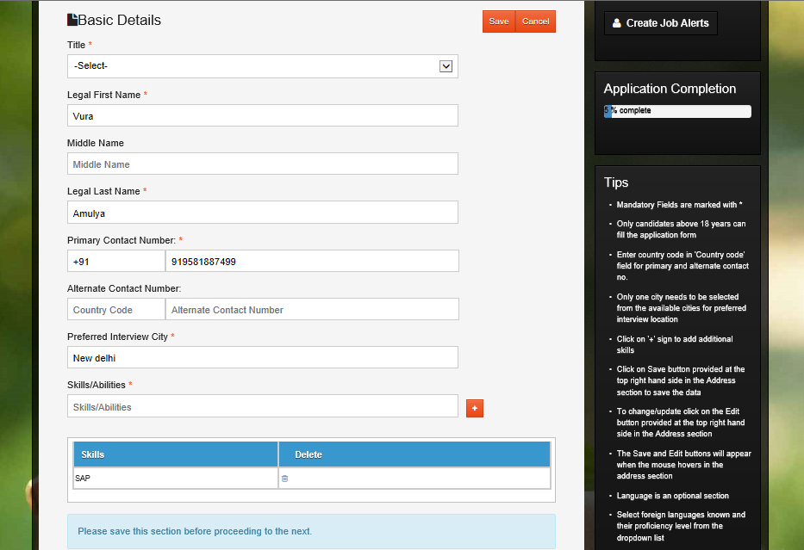

To save the data, please click on the ‘Save’ button. In case, you do not wish to save the data, you can click on the cancel button.

* **Correspondence Details -** this section will show your address

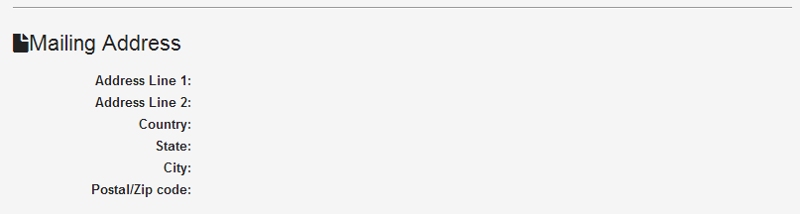

Clicking on “Edit” button will open the fields in editable mode. You will need to provide all the mandatory details and then click on ‘Save’.

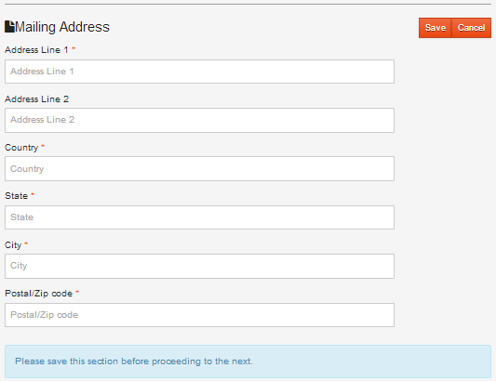

* **Language Proficiency Details -** This is an optional section which allows you to specify your proficiency in different languages.

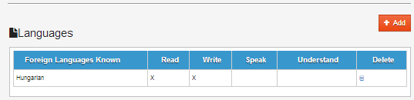

Clicking on “Add” button will allow you to add more languages. To save the data, please click on ‘Save’ tab.

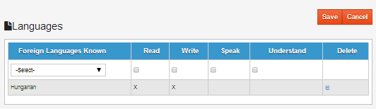

* **References -** This is an optional section used to list upto a maximum of two professional references

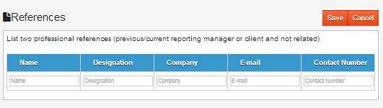

Clicking on “Add” button will open up the fields for additional details in editable mode. To save the data, please click on ‘Save’ tab.

* **Attachments -** In this section, you can upload your resume. At a time, only one resume file can be added. Photo upload will be mandatory here.

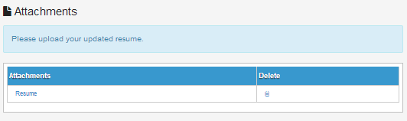

* **Summary of the Personal Information section:**

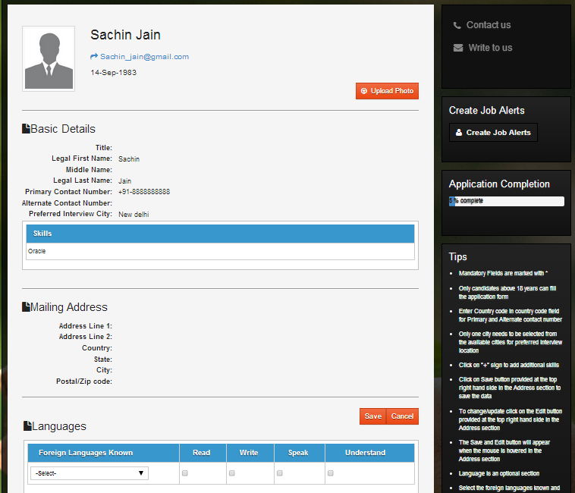

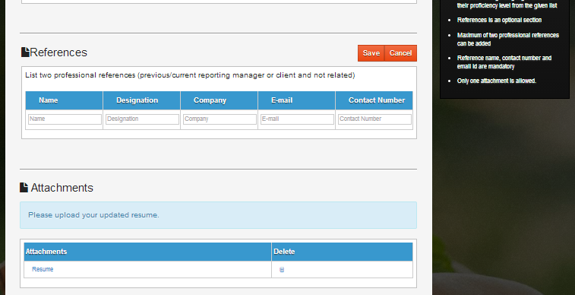

1. **Education -** This section will allow you to update the education details. There will be 4 different sections which you will need to fill up

* X/SSLC/Junior
* XII/SSC/High/Equivalent
* Graduation
* Post Graduation / Diploma / Others

X/SSLC, XII/SSC/Equivalent and Graduation details are mandatory to enter. If you have done a post-graduation, please enter the details accordingly. In case you wish to add another qualification, please click on ‘Add’ button in the Post Graduation / Diploma / Others section.

For every above section Clicking on “Edit” button will open up the fields in editable mode. To save the data, please click on ‘Save’ tab.

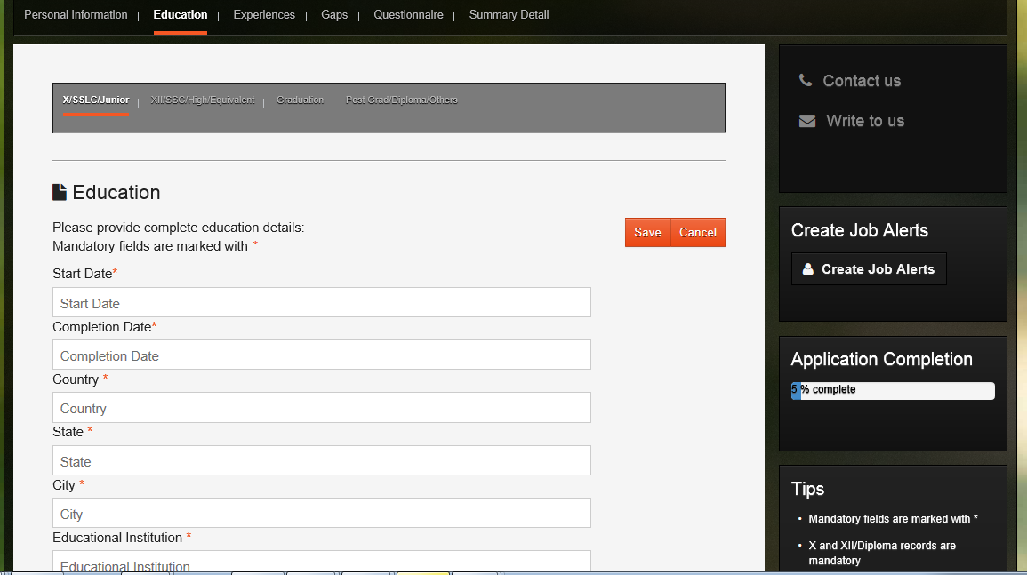

For 10th/12th records, the total marks obtained and maximum marks must be entered. The simple average percentage will be auto calculated.

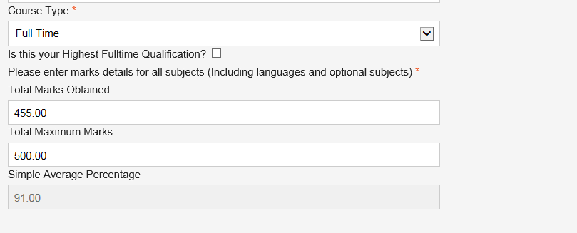

For Graduation/Post Graduation/Diploma records, the actual marks obtained and maximum possible marks of each semester/year must be entered. The semester/year (as applicable to you) can be added by using ‘Add’ button. The Simple Average Percentage will be auto calculated.

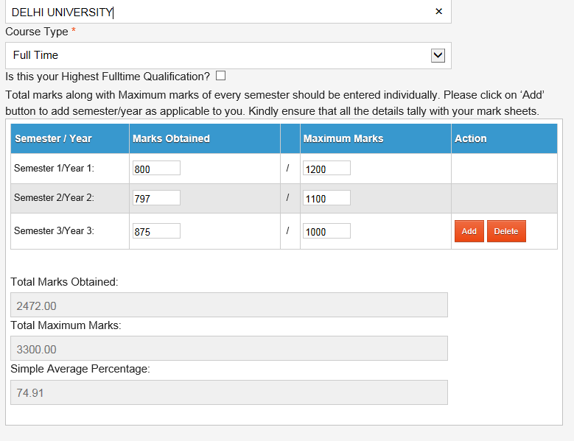

1. **Work Experience**

This section will allow the user to update the Work Experience details. There will be 3 different sections which user has to fill up

* **Total Experience**
* **Experience Details**
* **Compensation And Benefits**

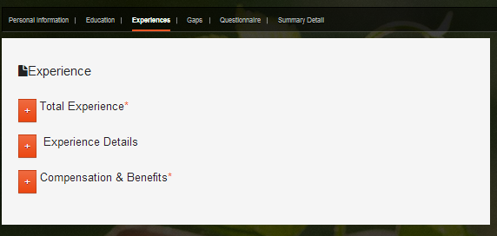

Please click on Edit button to fill the fields. More records can be added by clicking on the ‘Add New Work Experience’ button.

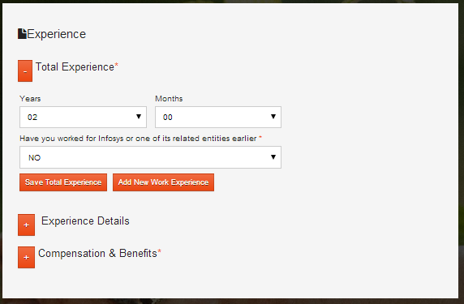

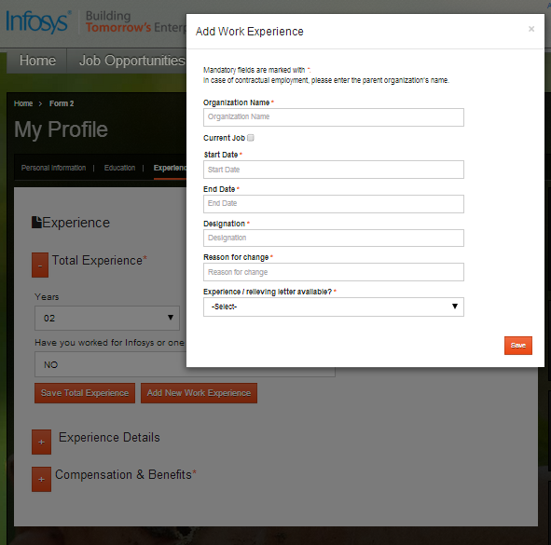

On clicking the Experience Details the below shown details will crop up, and details pertaining to the organization worked with, the start date, Role designation in last company, notice period and any legal obligations with current organization shall be asked for.

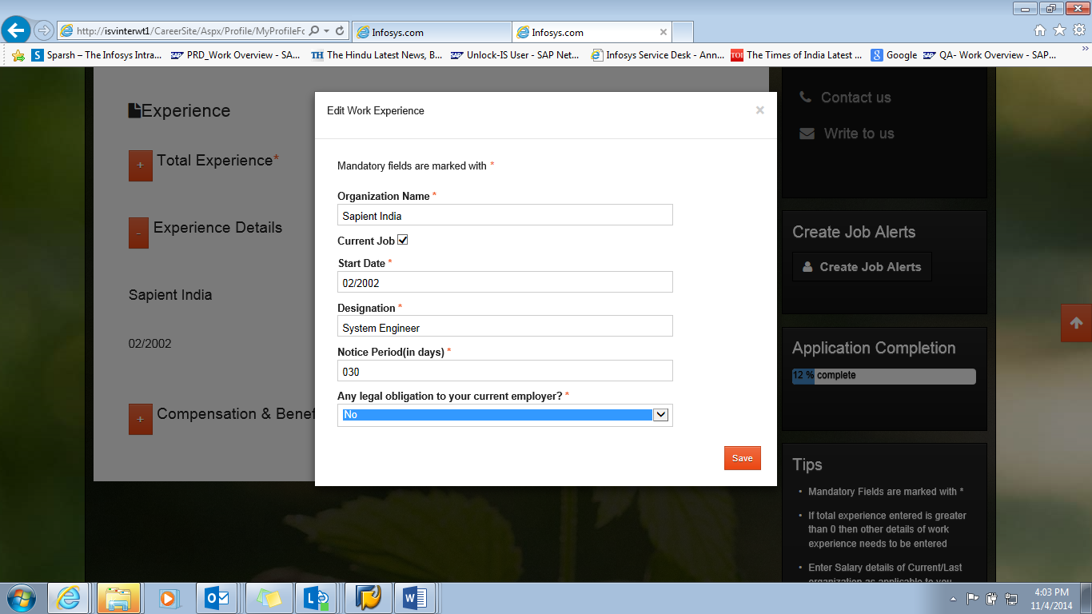

The Compensation and Benefits tab will prompt for salary details of current / last organization, expected revision of salary in current organization and salary expected at Infosys. Salary details like annual fixed salary / variable salary and other benefits need to be provided.

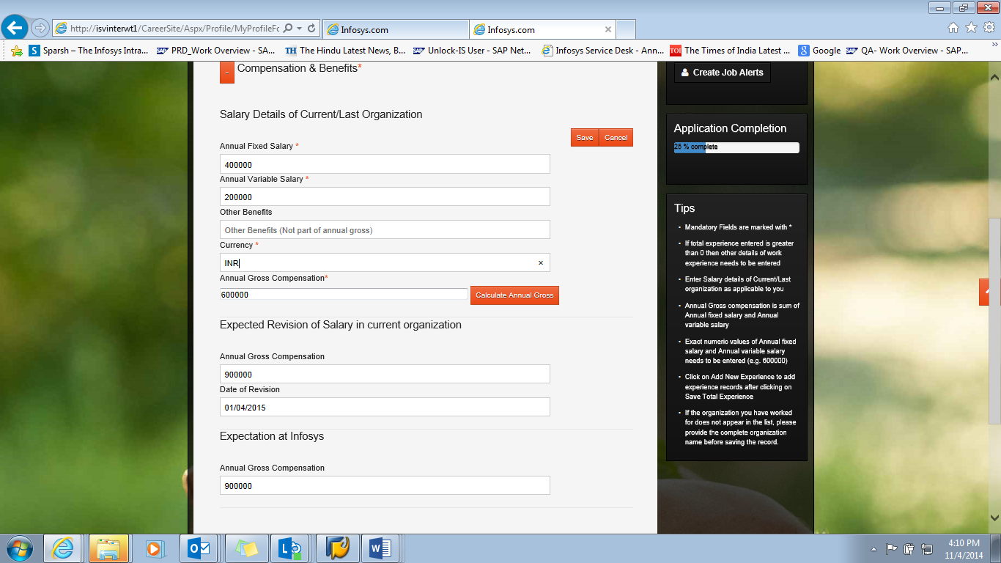

1. **Gaps**

Based on the information provided in Education and Work Experience sections, the gaps will be calculated and you will need to provide the reasons for the same.

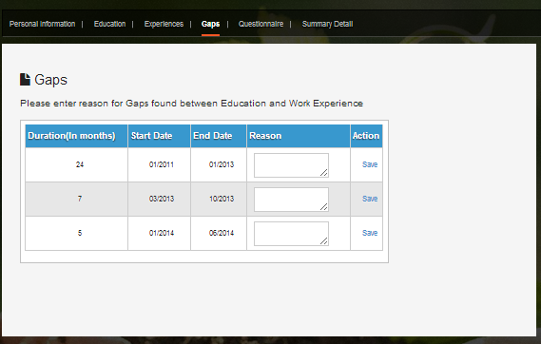

1. **Questionnaire**

All questions in this section are mandatory. The text boxes cannot be left blank. If your answer is ‘No’, please update “NA” wherever applicable in the corresponding text box.

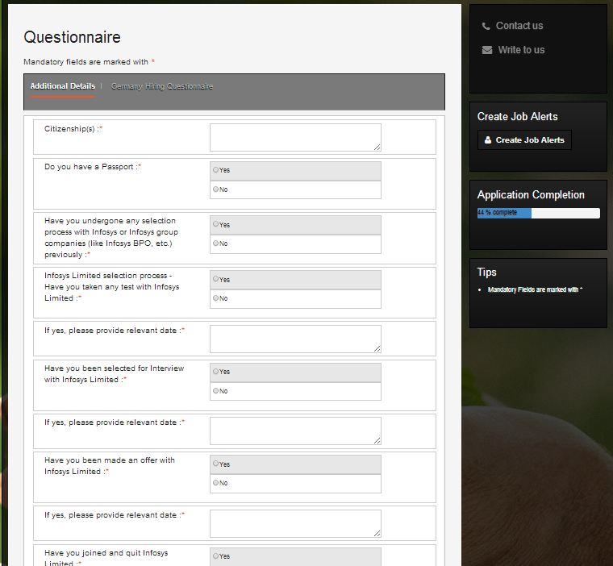

1. **Summary Details**

When you reach the ‘Summary Detail’ section, please go through all the sections that you have filled to ensure that all the details are filled correctly as per your supporting documents since post submission you will not be able to make any changes in the form.

* 1. In case you want to make any corrections, please click on the relevant section and make the changes.
  2. Once you have reviewed all the details, please read through the declaration and if you agree with it, please click on the checkbox as shown below and click on ‘Submit’.

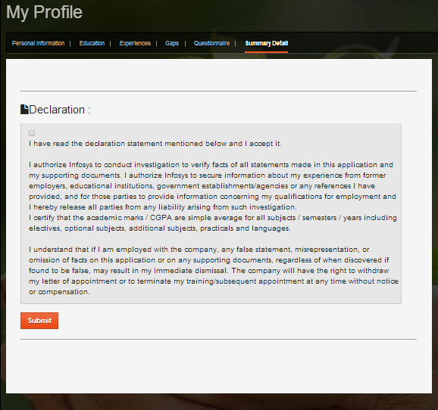

On clicking ‘Submit’, you will get the following message. If there are any changes to be made to the form please close this overlay and update. If there are no changes to be made, please proceed and click on the ‘Submit’ button.

The below message would appear which implies that the application form is submitted successfully.

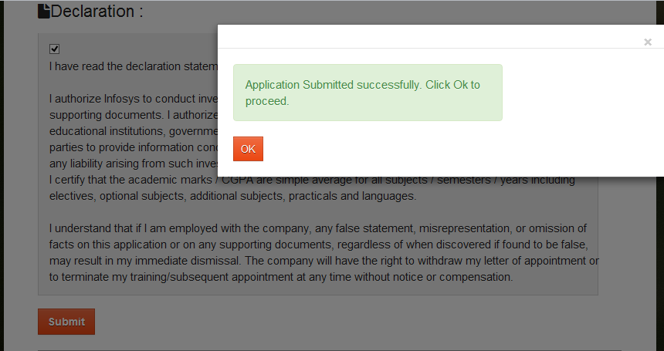

1. **Print out of Application form**

Once you have submitted the application form, please take a print out of application form available under My Applications section. You will need to carry the print out to the interview venue.

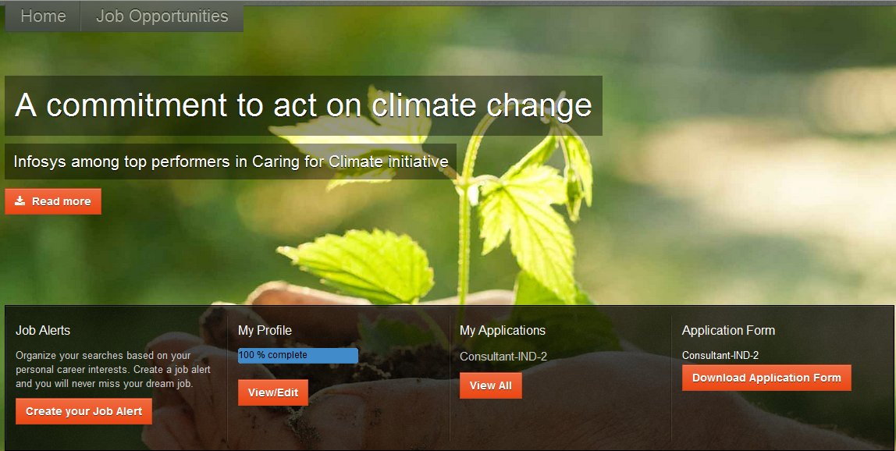

Go to My Applications sections then click on Refresh.

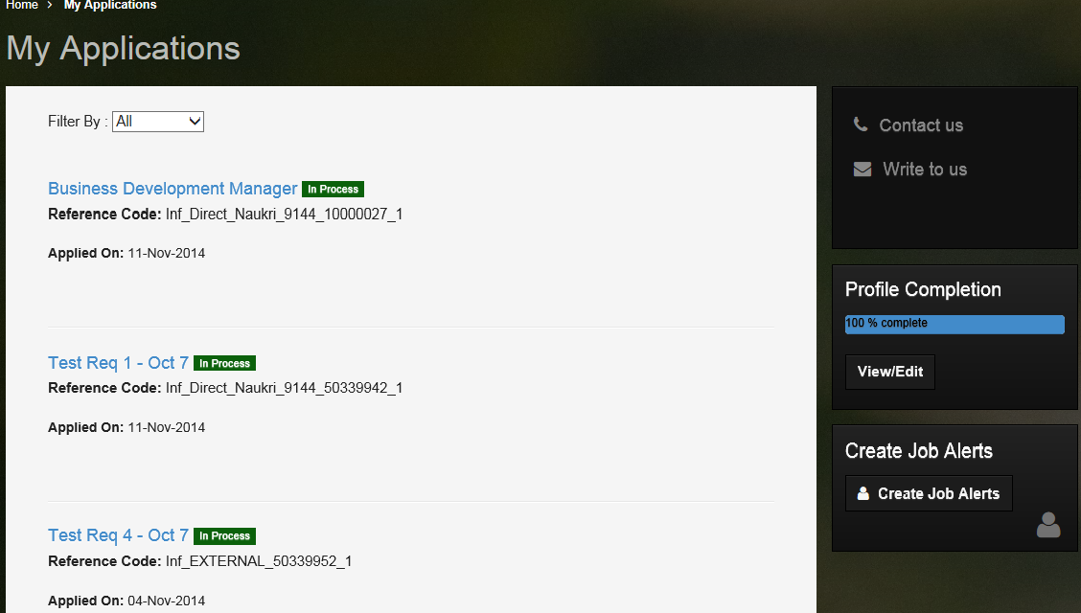

Click on “Download Application Form”. You will be prompted to either Open or Save the Application form for printing.

